Date: 26.09.2025
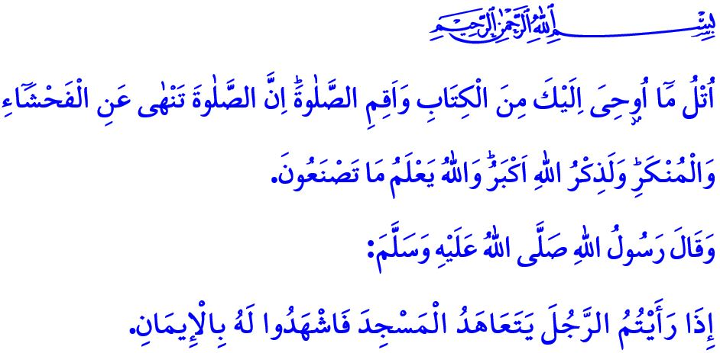
OUR PROPHET (SAW), THE MOSQUE, AND PRAYER
Honorable Muslims!
One of the fundamental principles of our sublime religion, Islam, is the prayer. Prayer is an act of worship that the Almighty Allah has commanded all prophets and their communities to observe. Prayer is the pillar of the faith, the ascension of the believer, and the reflection of faith in daily life. It is a manifestation of serenity, submission, and devoted servitude to Allah. Prayer, performed in full observance of its pillars, conditions, and proper etiquette, disciplines the nafs. It brings abundant divine blessings to our lives. It fills our homes with peace and tranquility. It protects us from worldly greed and ostentation. It refreshes and soothes our weary souls. It teaches us patience in the face of hardships and trials.
Dear Believers!
Prayer is not merely a set of prescribed movements; it is a roadmap that guides our lives and keeps us steadfast upon the straight path. Indeed, when we begin our prayer, we recite the opening takbir (takbir al-iftitah), affirming that there is no deity except Allah. Through the standing position (qiyam), we declare our resolve to stand for truth against falsehood and our refusal to consent to oppression or wrongdoing. Through the recitation (qiraat), we recite the Qur’an and affirm our commitment to applying its timeless message to every aspect of our lives. Through the bowing (ruku), we demonstrate that we will bow to none but Allah. Through the prostration (sajdah), we attain the peace and joy of closeness to our Lord. Through the salutation (salam), we convey the assurance that neither our hands nor our words will cause harm to anyone.
Esteemed Muslims!
For our beloved Prophet (saw), prayer was a duty of servitude never abandoned until the very end of his life. Even in the final days of his life, despite severe illness, he did not forsake praying with the congregation and went to the masjid to perform the prayer, however difficult it was. The Messenger of Allah (saw) regarded prayer as a shield, beginning his day with the Fajr prayer witnessed by the angels, saying, “Whoever prays the morning prayer is under the protection of Allah.” He considered abandoning a single obligatory prayer equivalent to losing the world and all within it, warning, “Whoever does not pray the Asr prayer, it is as if they have lost their family and wealth.” The Messenger of Allah (saw) would begin his day with the blessings of the Fajr prayer and conclude it with the tranquility of the ‘Isha prayer. He said, “If people knew the reward for the Fajr and ‘Isha prayers, they would come to the mosque even if they had to crawl.”
Dear Believers!
In the life of our beloved Prophet (saw), prayer was an act of worship that kept the servant’s connection with Allah alive, and mosques were the sacred places where this worship was brought to life. The Messenger of Allah (saw) said, “If you see a person consistently going to the masjid to pray, bear witness to their faith!” In this way, he regarded prayer and the mosque as two inseparable parts of a whole and a clear sign of faith. Indeed, mosques are the houses of Allah, branches of the Ka‘bah, the hearts of our cities, the foundation of our civilization, and sacred places that guarantee peace and tranquility. They are places where we stand shoulder to shoulder in serenity, strengthen our brotherhood, and enrich our lives with sound and authentic knowledge — sanctuaries of learning, wisdom, and spiritual insight.
Dear Muslims!
The mosque and prayer offer today’s people, caught in the grip of pleasure, haste, consumption, and isolation, a chance to breathe, find tranquility, and regain inner peace. They contribute to the promotion of social harmony. They instill identity and character in our children and youth, and nurture a sense of responsibility. They protect them from harmful habits and destructive ideologies, shaping them to be beneficial to their families, society, and humanity at large. Therefore, in accordance with the command of our Almighty Lord,
وَأْمُرْ اَهْلَكَ بِالصَّلٰوةِ وَاصْطَبِرْ عَلَيْهَاۜ لَا نَسْـَٔلُكَ رِزْقاًۜ نَحْنُ نَرْزُقُكَۜ وَالْعَاقِبَةُ لِلتَّقْوٰى
“Bid your people to pray, and be diligent in ˹observing˺ it. We do not ask you to provide. It is We Who provide for you. And the ultimate outcome is ˹only˺ for ˹the people of˺ righteousness.”, let us nurture our families in the practice of prayer with gentle words, a smiling countenance, and patient perseverance. Let us not prevent our children and our employees from praying out of concern for earning our livelihood. Let us not forget that the Messenger of Allah (saw) would awaken his daughter, Fatima (ra), and his son-in-law, Ali (ra), for the Fajr prayer as he was leaving for the masjid. Let us never overlook that our Prophet (saw), even in the final moments of his life, emphasized, “Pay careful attention to prayer!”
Dear Believers!
Every year, the first week of October, from the 1st to the 7th, is observed as “the Mosques and Religious Officials Week” in Türkiye. This year, inshallah, we will observe the week under the theme, “Our Prophet (saw), the Mosque, and Prayer”. On this occasion, I pray for mercy upon our hodjas who have contributed to the spiritual development of our noble nation throughout history, for the benefactors who took part in the construction of our mosques, and for all members of our community who have passed away; and I wish health and well-being for those who are still with us.

I would like to conclude this Friday’s khutbah with Verse 45 of Surah al-‘Ankabut: “Recite what has been revealed to you of the Book and establish prayer. Indeed, ˹genuine˺ prayer should deter ˹one˺ from indecency and wickedness. The remembrance of Allah is ˹an˺ even greater ˹deterrent˺. And Allah ˹fully˺ knows what you ˹all˺ do.”

Muslim, Masajid, 262.
Bukhari, Mawaqit al-Salat, 14.
Bukhari, Adhan, 9.
Tirmidhi, Iman, 8.
Ta-Ha, 20/132.
Tirmidhi, Tafsir al-Qur’an, 33.
Ibn Majah, Jana’iz, 64.
‘Ankabut, 29/45. General Directorate of Religious Services

